Beyond Abstention: Actionable Triage for Diabetic Retinopathy Screening
  - Focused student implementation plan and next-week update requirements
Primary objective | Route each image to the correct next action, not merely accept or reject a prediction.
Initial scope | Five-class diabetic retinopathy grading using public fundus datasets.
Update requested | Please provide a written and verbal update at next week's meeting.

1. Project focus
The project will study whether a diabetic retinopathy (DR) screening system can determine the appropriate next action for each fundus image. The goal is not to build another higher-accuracy DR classifier. The goal is to add a small, reliable routing layer to a frozen classifier and test whether it prevents clinically important failures without creating unnecessary expert workload.
The study should remain focused on one disease, one base classifier, one quality model, and one routing model. Bayesian uncertainty methods will be treated as comparison methods rather than as the main methodological contribution.

2. Research question and working contribution
Research question: Can an AI system determine not only whether to defer a DR prediction, but also why it should be deferred and what the appropriate next action should be?

Clinical significance
Most selective-prediction systems use a binary accept/defer decision. That decision is incomplete for screening practice. A poor-quality image should usually be reacquired; an adequate but ambiguous image should receive routine expert review; and a case with possible severe disease should receive priority review. Treating these situations as one generic rejection category wastes effort and can fail to prioritize the cases with the greatest potential harm.

Working methodological contribution
The working contribution is a hierarchical, reason-aware router that separates acquisition failure from diagnostic risk and distinguishes ordinary classification error from potentially harmful under-grading. This is a working hypothesis, not yet a novelty claim. The literature review must establish how it differs from existing uncertainty-aware DR systems and multi-expert deferral routers.
Initial scope boundary: Do not add a new DR backbone, another eye disease, lesion segmentation, multi-expert allocation, conformal guarantees, or clinical deployment to the initial study.

3. Required system output
Action | When it should be used | Interpretation
AUTO-GRADE | Image is adequate and estimated clinical risk is low. | Use the model's screening grade without immediate specialist review.
RE-IMAGE | Image is not adequate for reliable grading. | Acquire another image instead of sending a non-diagnostic image for interpretation.
ROUTINE REVIEW | Image is adequate, but the grade is uncertain or likely referable without an urgent severe finding. | Queue for standard expert review.
PRIORITY REVIEW | Severe/PDR probability or harmful under-grading risk is high. | Move the case ahead of routine review.
Important: Priority review must not depend on low confidence alone. A high-confidence Severe or PDR prediction should still be prioritized. AUTO-GRADE refers to a screening workflow decision, not an autonomous treatment decision.

4. Proposed workflow
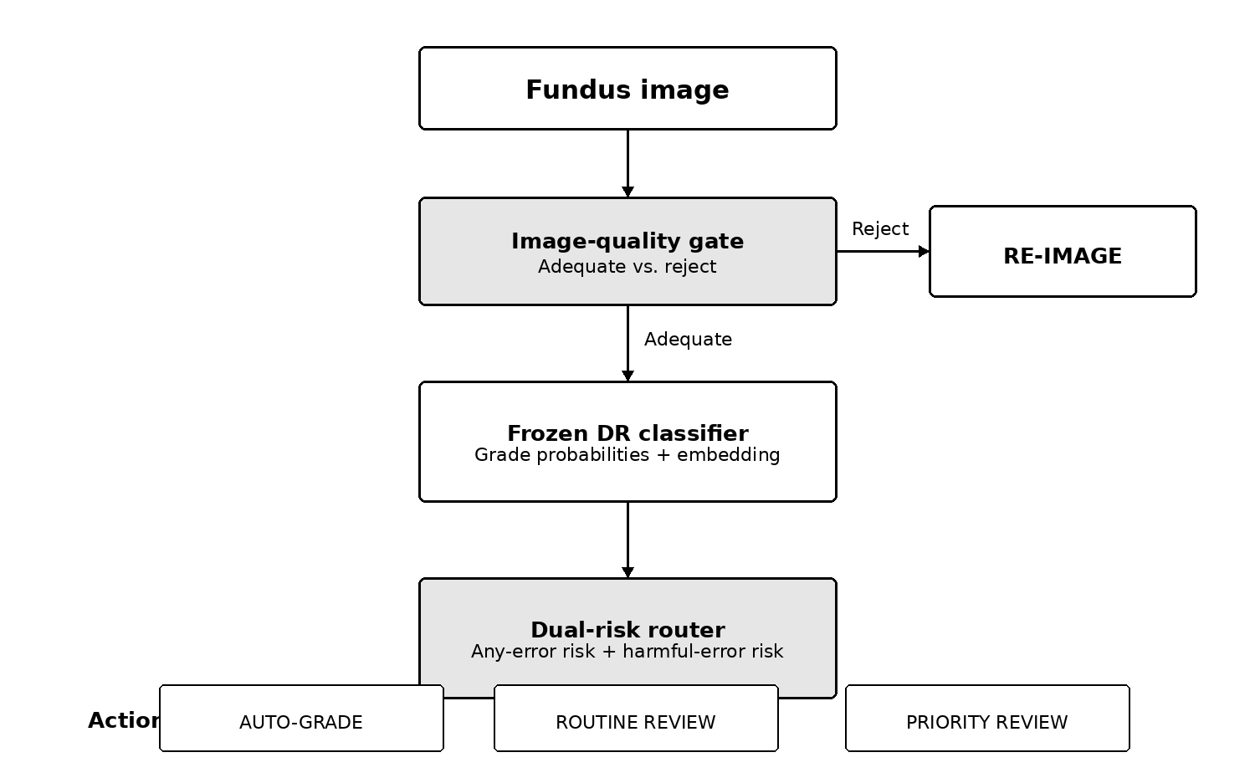
Figure 1. Focused end-to-end workflow. The quality gate is evaluated before diagnostic routing.

5. Data plan and split discipline
Dataset | Role | Required labels | Use in this study
EyePACS | Primary DR dataset | Five-class DR grade | Train and internally evaluate the frozen base classifier.
EyeQ or DeepDRiD | Image-quality dataset | Adequate/usable/reject quality label | Train or evaluate the image-quality gate.
APTOS or DDR | External DR dataset | Five-class or harmonizable DR grade | Test whether risk ranking and action thresholds transfer across datasets.
Use patient-level splitting whenever patient identifiers or paired-eye information are available. Do not allow images from the same patient to appear in training and testing partitions.
Partition | Suggested proportion | Purpose
Base-model training | 60% | Fit the DR classifier only.
Base-model validation | 10% | Select base-model checkpoints and hyperparameters.
Router training | 15% | Generate frozen-model predictions and train the risk router.
Threshold calibration | 5% | Set review-budget and action thresholds.
Final internal test | 10% | Report all final internal results once.
No leakage: The router must not be trained on predictions from images used to fit the base classifier. A frozen classifier should generate router-training labels on a disjoint partition. Keep the final test set untouched until the method and thresholds are fixed.

6. Technical implementation

6.1 Base DR classifier
- Use one standard backbone: EfficientNet-B0 or ResNet-50.
- Train a five-class classifier for grades 0 through 4.
- Freeze the selected checkpoint before router development.
- Report quadratic weighted kappa, macro F1, class-wise sensitivity, and confusion matrix.

6.2 Structured output contract
For every image in the router-training, calibration, and test partitions, the base pipeline must produce the same structured record.
Field | Example or format | Purpose
image_id, patient_id | String identifiers | Track samples and verify patient-level separation.
y_true, y_pred | Integer grade 0-4 | Define correctness and severity of error.
p0 ... p4 | Five probabilities | Primary diagnostic-confidence input.
entropy | Single numeric value | Simple uncertainty baseline.
embedding_path | Path to .npy or indexed array | Store the penultimate feature vector without placing a long vector in the CSV.
quality_score | Probability of adequate image | Input from the image-quality gate.
dataset, split | Source and partition name | Prevent accidental mixing and support external evaluation.

6.3 Image-quality gate
Start with a binary adequate-versus-reject quality classifier using EyeQ or DeepDRiD labels. The first objective is a stable RE-IMAGE decision, not a new retinal image-quality architecture. Report sensitivity for reject-quality images and the false re-image rate among adequate images.

6.4 Dual-risk router
Use a small multilayer perceptron on the frozen class-probability vector and penultimate embedding. A probability-only model should be implemented first; the embedding should be added as a controlled ablation. The router should produce two outputs:
- Any-error risk: probability that the frozen classifier's grade is incorrect.
- Harmful-error risk: predicted severity of the clinical error, with larger values for missed referable disease and severe under-grading.
The router-training targets are computed only after the base classifier is frozen:
Any-error target | e = 1 if predicted grade differs from the true grade; otherwise 0.
Harm target | c = C(true grade, predicted grade), using the asymmetric cost protocol below.

6.5 Initial clinical-cost protocol
The following table is an initial computational protocol. It must be checked against the selected DR referral definition and reviewed by an ophthalmic collaborator before it is presented as clinically validated.
Error type | Initial cost | Reason
Correct grade | 0 | No classification error.
Adjacent-grade error without missed referral | 1 | Limited ordinal disagreement.
Other error of two or more grades | 3 | Substantial grading disagreement.
True grade >= 2 but predicted grade < 2 | 4 | Potentially missed referable DR.
True grade 3-4 predicted as grade 0-1 | 5 | Dangerous under-grading of Severe/PDR disease.

6.6 Action policy and threshold selection
Ordered rule | Implementation
1. RE-IMAGE | If the predicted image-quality score is below the adequacy threshold.
2. PRIORITY REVIEW | If Severe/PDR probability or predicted harmful-error risk exceeds its calibrated threshold.
3. ROUTINE REVIEW | If referable-DR probability or any-error risk exceeds its calibrated threshold.
4. AUTO-GRADE | If none of the preceding conditions is met.
Thresholds must be selected on the calibration partition, not on the final test set. Compare methods at matched review budgets, such as routing the same 10%, 20%, and 30% of adequate images to routine or priority review.

7. Baselines and experiments
Method | What it tests | Required implementation
Maximum softmax probability | Whether confidence alone is sufficient. | Rank by 1 - maximum class probability.
Predictive entropy | Whether the full probability distribution improves rejection. | Rank by entropy.
MC Dropout | Whether a standard approximate Bayesian method improves uncertainty. | Use repeated stochastic forward passes.
Generic error predictor | Whether predicting any error is sufficient. | Use the same router capacity with only the binary error target.
Proposed dual-risk router | Whether severity-sensitive risk improves actionable routing. | Predict any-error and harmful-error risk.

Primary comparison
Primary endpoint: At the same expert-review rate, determine which method leaves the fewest missed referable and Severe/PDR cases in AUTO-GRADE.

Category | Metric | Interpretation
Primary | Severe/PDR or referable false-negative rate among AUTO-GRADE cases | Measures residual clinical risk after routing.
Primary | Expert-review rate | Measures routine and priority workload.
Primary | Reject-quality sensitivity and false re-image rate | Measures whether the quality gate sends the correct images for reacquisition.
Secondary | Risk-coverage curve and AURC | Measures general selective-prediction quality.
Secondary | Failure-prediction AUROC and calibration | Measures risk ranking and probability quality.
Secondary | External-dataset results | Measures transfer across acquisition and population differences.

Required ablations
- Probability vector only versus probability vector plus embedding.
- Generic binary error target versus severity-sensitive harm target.
- Single binary accept/defer policy versus the proposed action policy.

8. Work division
Owner | Primary responsibilities | Concrete outputs
Siddhartha | Dataset preparation, patient-level splits, base DR classifier, image-quality model, and structured output export. | Frozen checkpoint; metrics; CSV/NPY output contract; quality-gate results.
Anay | Risk-target generation, generic error predictor, dual-risk router, threshold calibration, baselines, and evaluation. | Router code; risk scores; matched-budget comparison; ablation tables.
Joint | Literature gap analysis, action/cost definitions, integration, external evaluation, and interpretation. | Revised research question; integrated pipeline; weekly report; manuscript outline.

9. Update required next week
Please provide a short written update before next week's meeting and be prepared to walk through the items below. Full model results are not expected yet; the purpose of the update is to confirm that the problem, data, labels, and interfaces are correct before substantial implementation begins.
Deliverable | Required evidence | Owner | Minimum status
Focused literature table | Compare no more than 6 closely related papers by task, uncertainty method, routing action, severity handling, datasets, and limitation. | Joint | Complete table and one-paragraph gap statement.
Dataset audit | Confirm access, label definitions, patient identifiers, image counts, class balance, and planned split for each dataset. | Siddhartha | CSV schema and verified sample counts.
Structured output prototype | Run the frozen or preliminary classifier on at least 20 images and export the agreed fields. | Siddhartha | Example CSV plus embedding file.
Risk and action definitions | Write the any-error label, harm-cost protocol, and ordered four-action rule in code-ready form. | Anay | One-page specification with pseudocode.
Baseline plan | State how confidence, entropy, MC Dropout, and the generic error predictor will be compared at matched review rates. | Anay | Experiment matrix with primary metric.
Blockers and next steps | List unresolved data, compute, label, or implementation issues and a two-week task sequence. | Joint | Concise list with owners.
Expected next-week conclusion: The team should be able to explain, in one sentence, how the proposed router differs from a standard uncertainty-based rejection system and show that the required data and training targets can be constructed without leakage.

10. Initial reading list
- Jaskari et al. (2022), Uncertainty-Aware Deep Learning Methods for Robust Diabetic Retinopathy Classification, IEEE Access. Read paper
- Band et al. (2021), Benchmarking Bayesian Deep Learning on Diabetic Retinopathy Detection Tasks, NeurIPS Datasets and Benchmarks. Read paper
- Ayhan et al. (2020), Expert-Validated Estimation of Diagnostic Uncertainty for Deep Neural Networks in Diabetic Retinopathy Detection, Medical Image Analysis. Read paper
- Mozannar and Sontag (2020), Consistent Estimators for Learning to Defer to an Expert, ICML. Read paper
- Fu et al. (2019), Evaluation of Retinal Image Quality Assessment Networks in Different Color-Spaces, MICCAI. Read paper
- Liu et al. (2022), DeepDRiD: Diabetic Retinopathy-Grading and Image Quality Estimation Challenge. Read paper

